# Implement Spring Security with Authentication – OUTPUT

**Main Dashboard:**

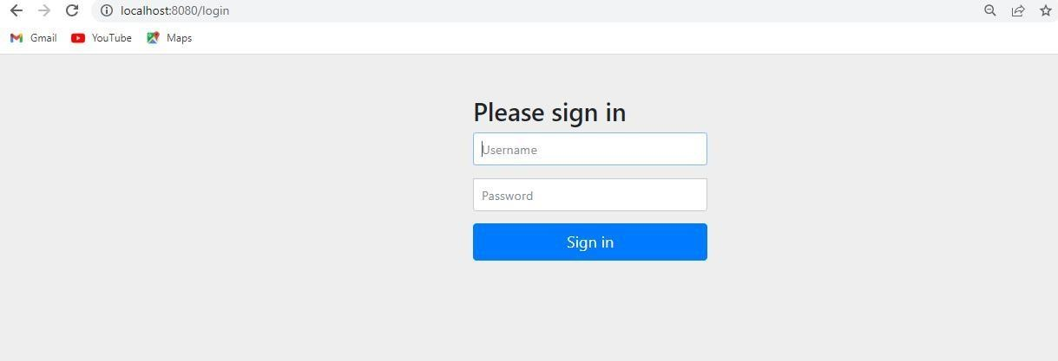

**if we enter wrong credentials**

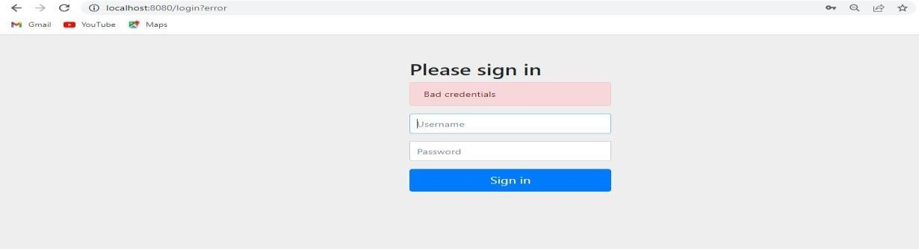

**Valid Credentials:**

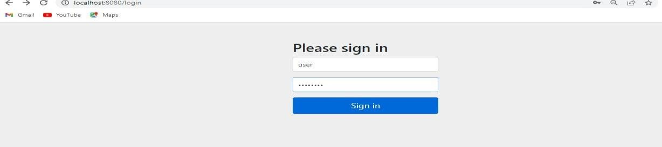

**final output :**

